LO4: Digital Maturity Diagnostics & Roadmaps
First: What is Digital Maturity?
Digital maturity refers to how effectively an organisation uses digital technology, data, processes, people and organisational culture to achieve its business goals.
It is not simply about how much technology a company owns.
For example:
Company A has 100 computers but still uses paper forms and makes decisions based on assumptions.
Company B has fewer technologies but uses cloud systems, data analytics, automation and digital processes effectively.
Company B may have higher digital maturity.
Four important pillars:
- Digital Culture & Leadership
- Technology Stack Architecture
- Data & Analytics Capabilities
- Operations & Process Automation

1. Digital Culture & Leadership
What does it mean?
This refers to whether the organisation's leaders and employees are willing and able to adopt digital ways of working.
It includes:
- Willingness to innovate
- Employee digital skills
- Leadership support
- Data-driven decision-making
- Experimentation
- Ability to adapt to change

Real-world example: DBS Bank
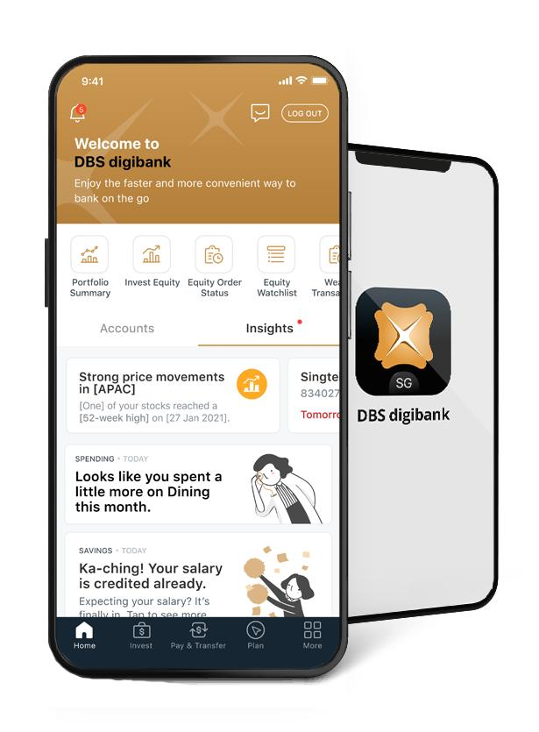

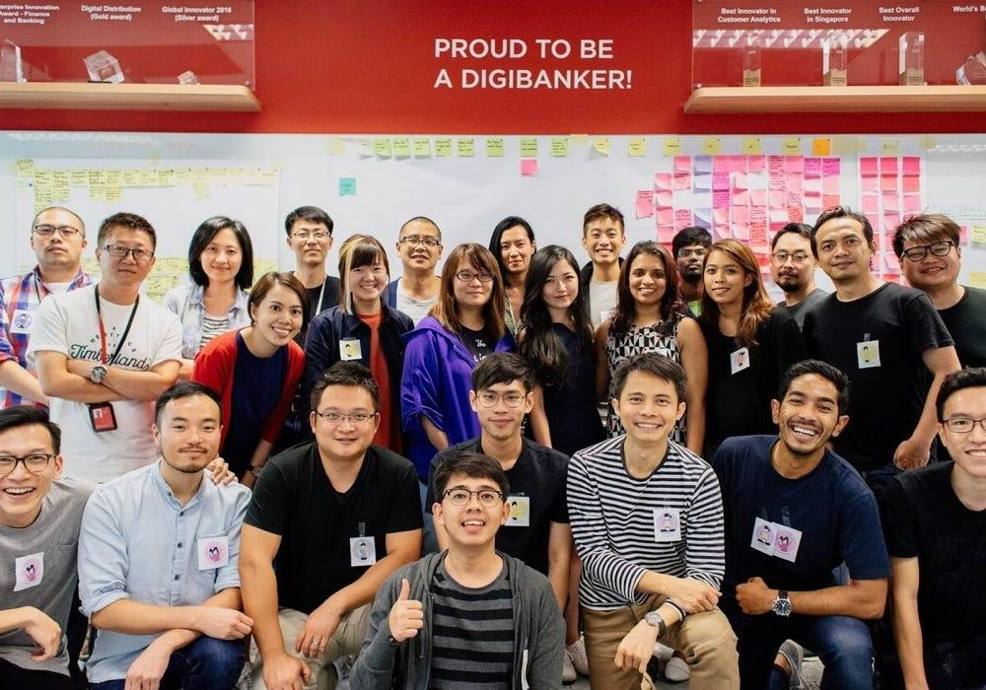

A bank cannot become digitally mature simply by creating a mobile banking app.
It also needs employees and managers who understand:
- Digital customer behaviour
- Data
- Cybersecurity
- AI
- Agile development
- Digital products
Example scenario
Imagine DBS wants to introduce an AI-powered financial assistant.
A low-maturity organisation might say:
"We bought an AI system. IT will take care of it."
A more digitally mature organisation asks:
"How can AI improve the customer experience, and how should our employees, processes and policies change to support it?"

Key lesson
Digital transformation is a people and culture transformation, not just a technology project.

2. Technology Stack Architecture
What does it mean?
This refers to the technology foundation that allows different digital systems to work together.
The slide specifically mentions:
- Cloud-native systems
- API readiness
- Security compliance
Think of it as the organisation's digital infrastructure and plumbing.
Real-world example: Grab
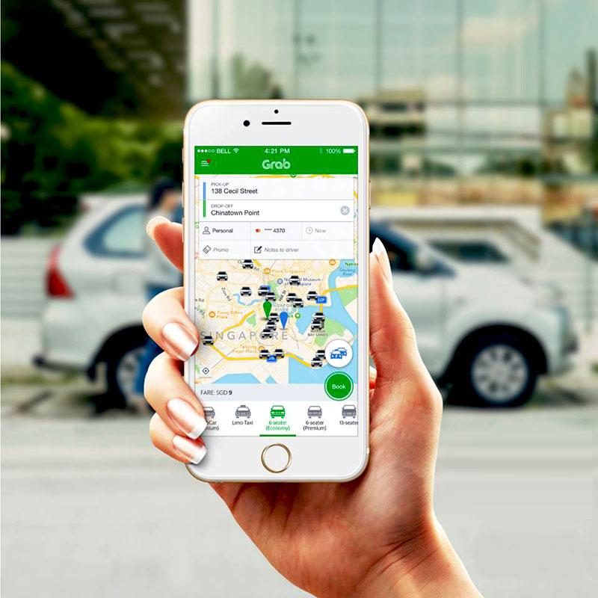
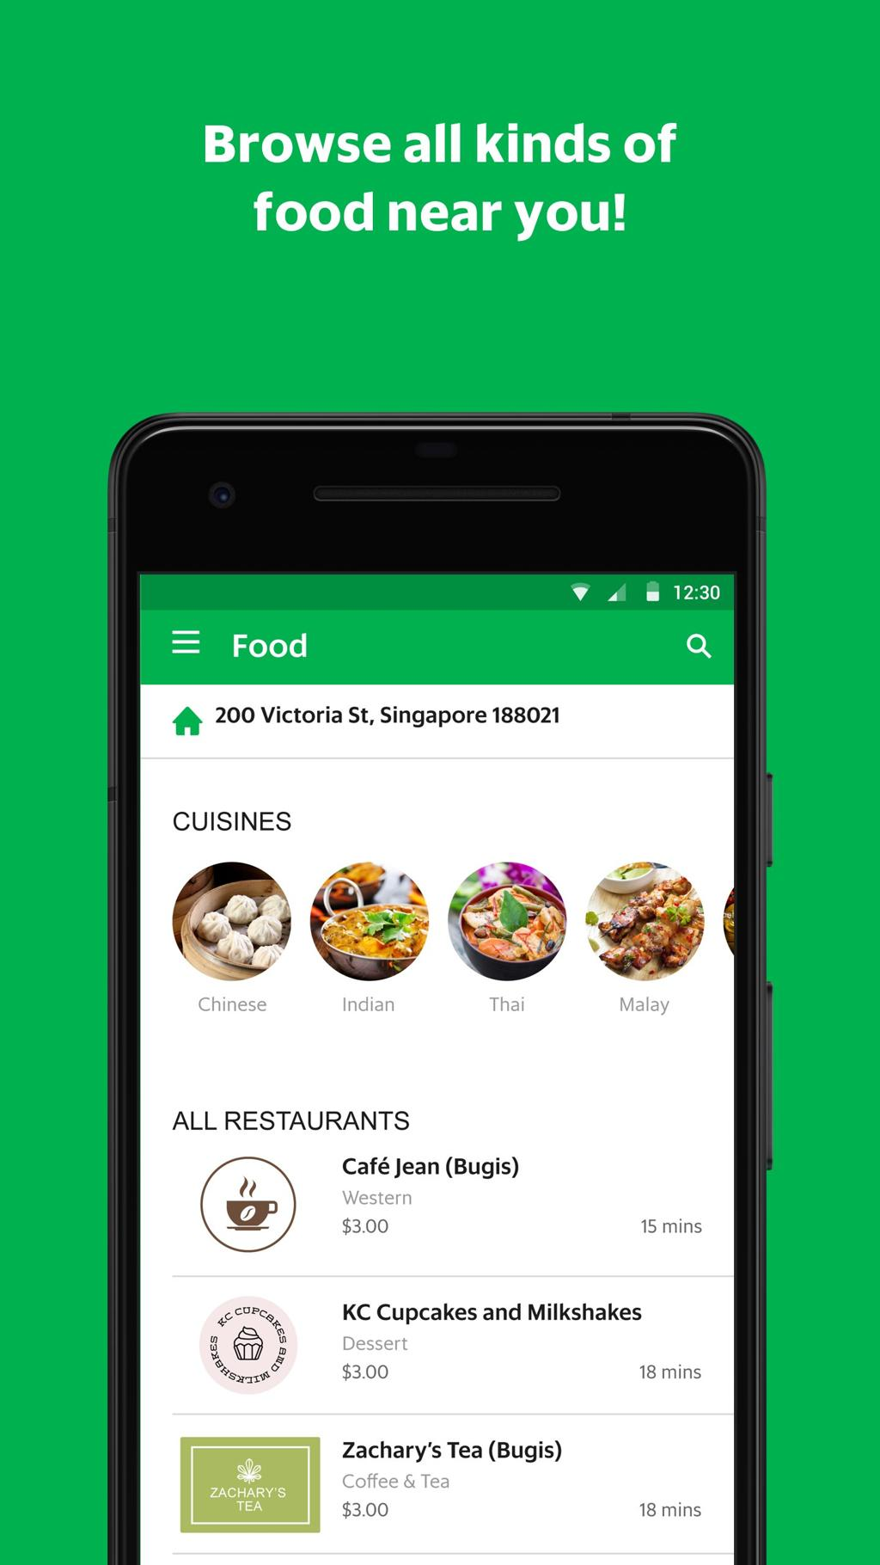
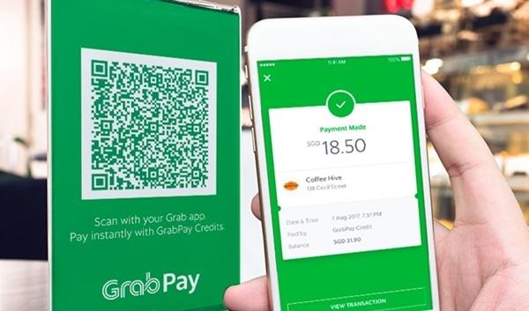

A platform such as Grab provides multiple services through digital technology.
For example:
Ride booking
Food delivery
Payments
Customer accounts
Driver applications
Restaurant applications
These services need to communicate with each other.
For example:
Customer places food order
↓
Restaurant receives order
↓
Payment is processed
↓
Delivery partner is assigned
↓
Customer tracks delivery
↓
Customer receives notification
This requires an integrated technology architecture.
Low maturity
Systems are isolated:
POS ❌ CRM ❌ Website ❌ Mobile App
Employees manually transfer information between systems.
High maturity
Systems communicate through APIs:
POS ↔ CRM ↔ Mobile App ↔ Payment ↔ Delivery ↔ Analytics
Key lesson
Digital maturity requires technology systems that can communicate, scale and operate securely—not just individual applications.

3. Data & Analytics Capabilities
What does it mean?
A digitally mature organisation doesn't simply collect data.
It can turn data into:
Information → Insights → Decisions → Action
The slide mentions:
- Real-time telemetry
- Predictive insights
- Unified data models
Real-world example: Netflix
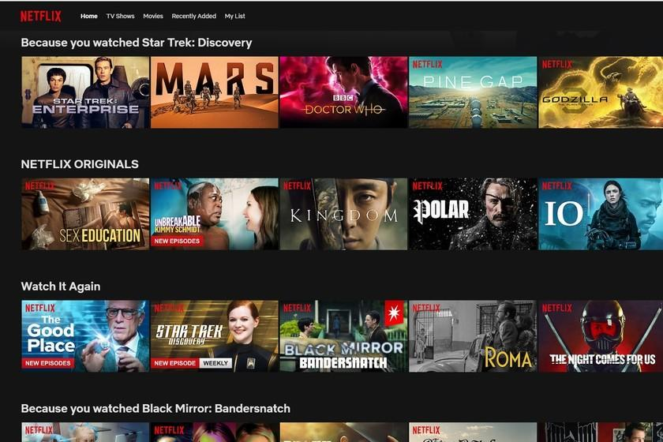

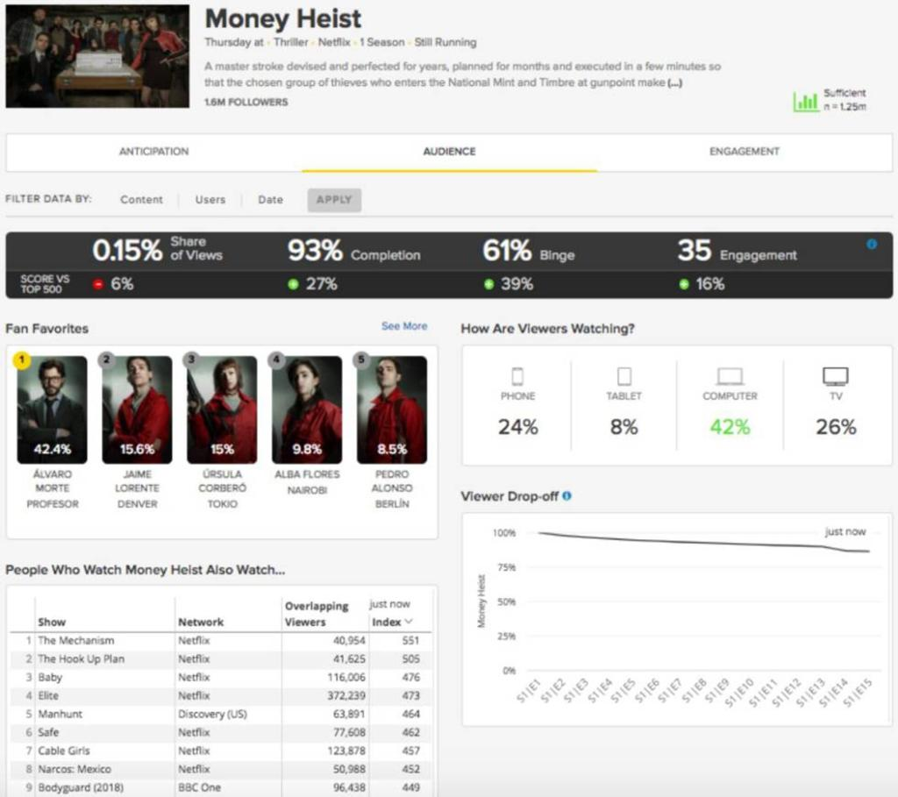
Netflix can use viewing behaviour to understand customer preferences.
For example:
Customer watches three Korean dramas.
The system analyses viewing behaviour.
↓
It identifies patterns.
↓
It recommends other relevant content.
↓
Customer discovers another programme.
↓
Customer continues using Netflix.

Low data maturity
The company might simply collect:
Customer name + email + purchase history
but doesn't use the information effectively.
High data maturity
The organisation combines:
Customer data + behavioural data + transaction data + operational data
and uses analytics/AI to make decisions.
Key lesson
Data becomes valuable when an organisation can use it to make better decisions and improve customer experiences.

4. Operations & Process Automation
What does it mean?
This refers to using technology to automate repetitive, manual or rule-based processes.
Examples include:
- Automated invoices
- Chatbots
- Automatic notifications
- Workflow automation
- Robotic Process Automation (RPA)
- Automated testing and deployment
- Automated customer onboarding
Real-world example: Amazon
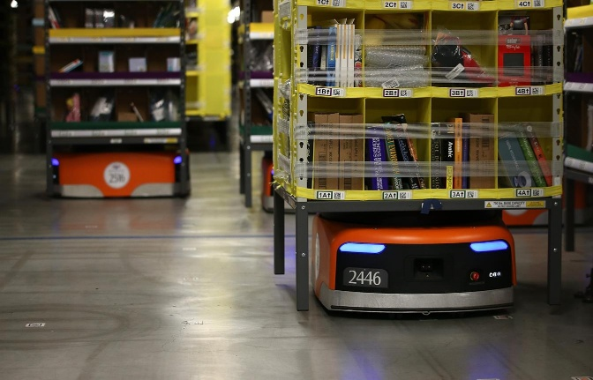
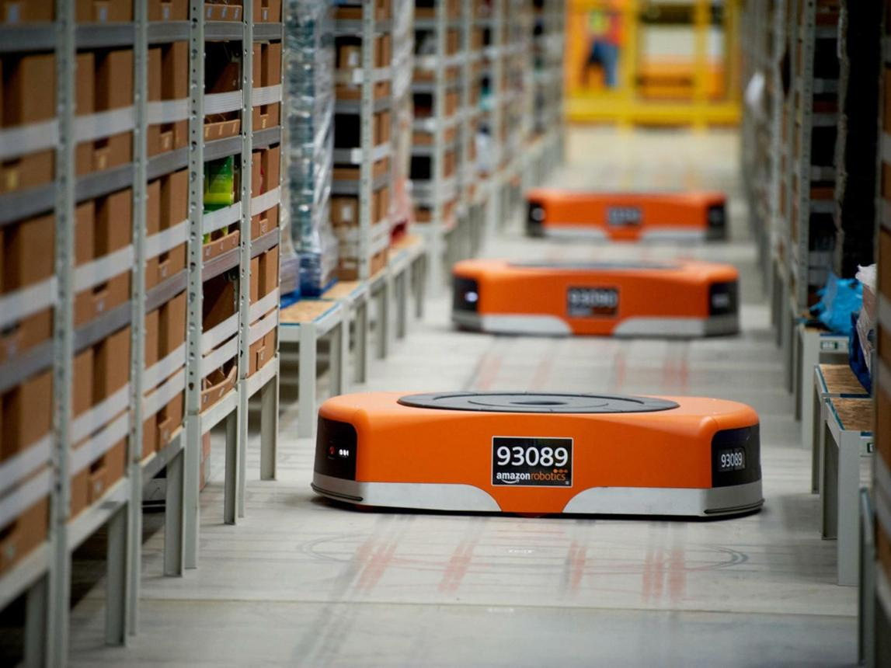
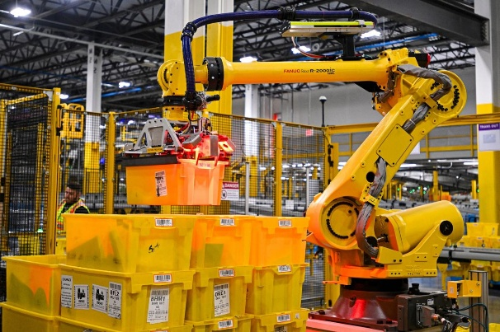
Amazon uses extensive technology and automation within its fulfilment operations.
Imagine a customer orders:
Laptop
The digital system can trigger a series of processes:
Order received
↓
Inventory checked
↓
Warehouse identifies item
↓
Item picked
↓
Packed
↓
Shipping label generated
↓
Delivery process begins
Much of this workflow can be digitally coordinated and automated.
Low maturity
Customer order → Employee prints order → Employee checks inventory → Employee manually enters information → Employee contacts delivery company
Higher maturity
Customer order → Integrated system → Automated inventory → Automated workflow → Delivery tracking
Key lesson
Automation reduces manual work, errors and processing time while allowing employees to focus on higher-value activities.

